**Power BI**

**Activity 1:**

Kindly upload the two files to Power BI and make to do the necessary changes to following table within Power Query before loading the newly changed data to Power BI

DATASET

* Remove Errors for all columns
* Remove the following columns ("Year", "Month", "M-Y","increment_id, ”MV" & “Grand Total”)
* Make sure the data type are correct for each column
* Change the name of column “category_name_1” to “Category Name”

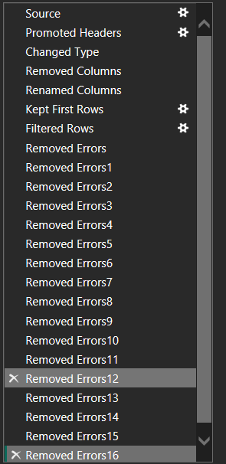

**CALENDAR:**

* Add 2 columns to it. Start of the week and Month name
* Select the correct data type for the following column

"Year", text

"Month", text

* Make sure all data type are correct

You should have the following as shown below:

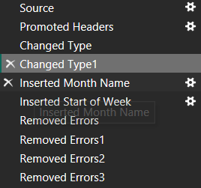

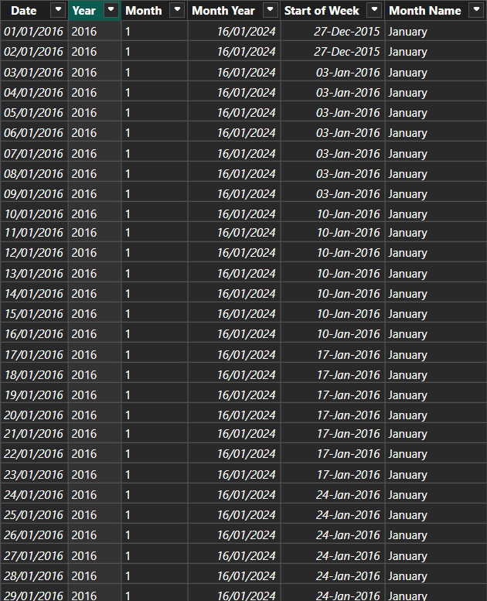

**Activity#2:**

Calculated Column

* Bill Total (item price multiplied by quantity AND then subtracted by discount amount)

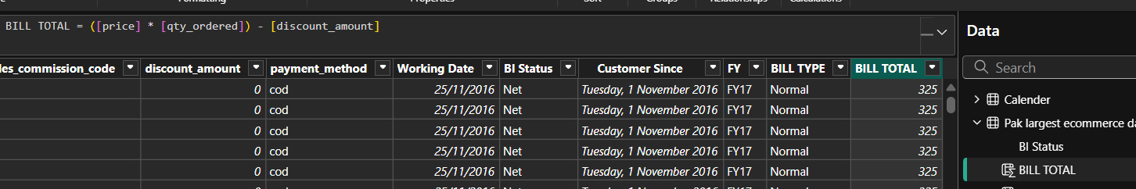

* Bill Type (if bill total greater than 1000, show “High” otherwise show “Normal”)

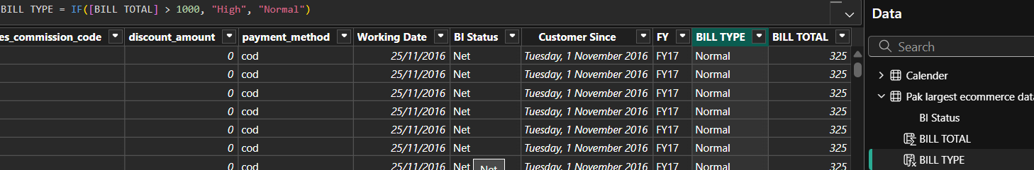

**Measure:**

* Total Sales (SUM of Bill Total)

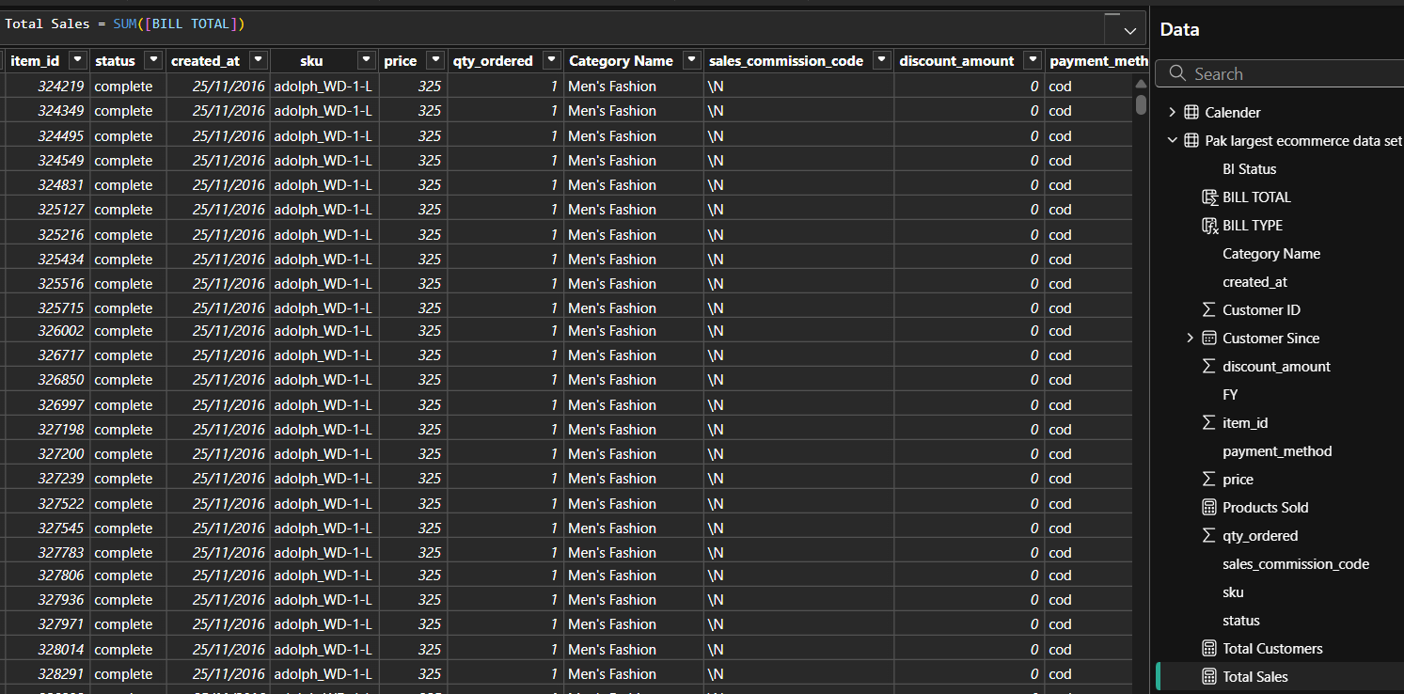

* Products Sold (DISTINCT COUNT of sku)

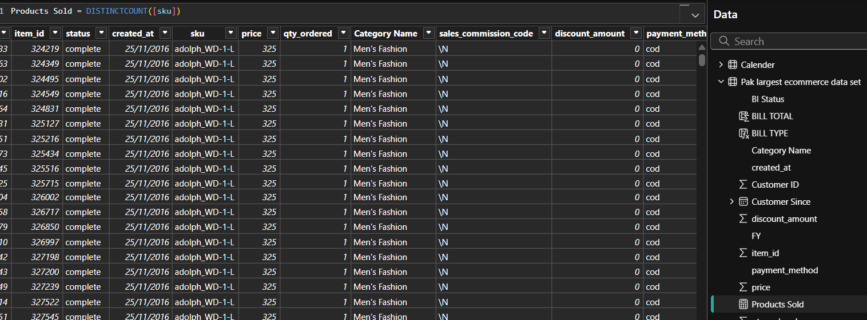

* Total Customer (COUNTROWS of customer ID) find distinct customers.

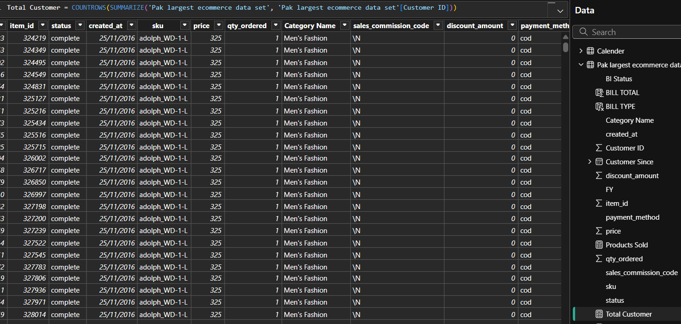

**Overview Page**

* **One chart from the other 3 pages which you think is important to show in this page**
* **Using a suitable chart, show the bill total with respect to the week**
* **Using a suitable chart, show bill total with respect to category**
* **One slicer chart which should be date filter**

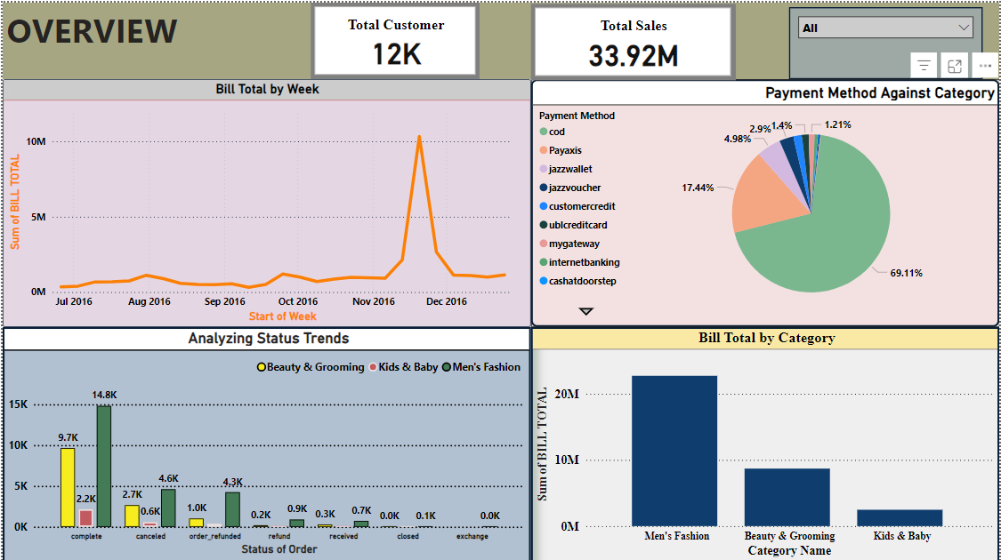

**Men’s Fashion Page only contains men’s fashion category data**

* One chart which must contain data compared with a date/time data using the correct chart
* One unique chart which should not be repeated in other page (excluding Overview)
* Remaining 3 chart, can be of your preference but make sense of what is showing alongside using the correct chart for it

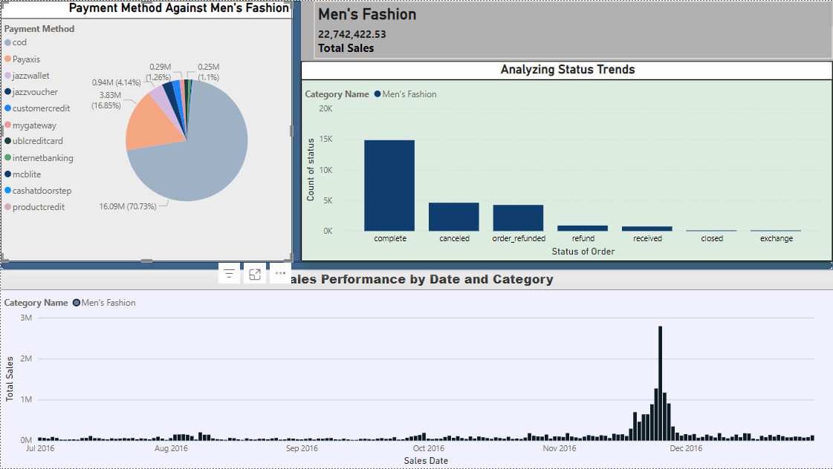

**Beauty and Grooming Page contains Beauty and Grooming category data**

* One chart which must contain data compared with a date/time data using the correct chart
* One unique chart which should not be repeated in other page (excluding Overview)
* Remaining 3 chart, can be of your preference but make sense of what is showing alongside using the correct chart for it

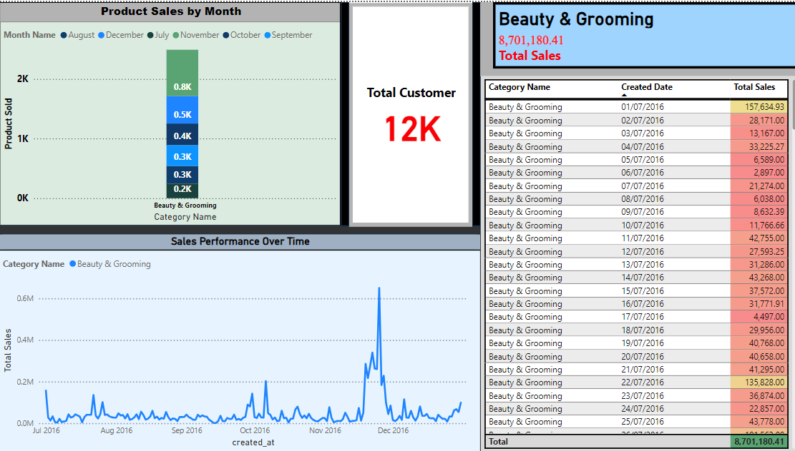

Kids and Baby Page contains Kids and Baby category data

* One chart which must contain data compared with a date/time data using the correct chart
* One unique chart which should not be repeated in other page (excluding Overview)
* Remaining 3 chart, can be of your preference but make sense of what is showing alongside using the correct chart for it

